Creative coding Project: Pokemon Timetable

Step 1: Setting the Concept

I had the idea of taking my Pokémon draft league that I did over the summer holiday as my focus for my dead data project. It is fun as it involves a video game I enjoy and it also helped with the data-making phase, as all the battles are recorded on a combination of discord and an excel sheet with the links.

The concept is to make a drawing using this program as it detects the battles and creates a small graph showing how well each Pokémon from my team did in each fight. The drawing will consist of 12 lines split into 7 columns where each column represents one of the battles in ascending order (based on the order I played them) and the other lines represent how well a certain Pokémon did in each Battle.

There will be 4 symbols that can be written on the timetable that shows different actions in the battle:

{ } = The pokemon is not currently in this battle

No curly brackets = The pokemon is in the battle and will have the other symbols below

--|-- = The pokemon got a KO

-- X -- = The pokemon has fainted

[-- S -- = The pokemon has played a supporting move or set up (scrapped due to implementation issues) ]

Paper plan

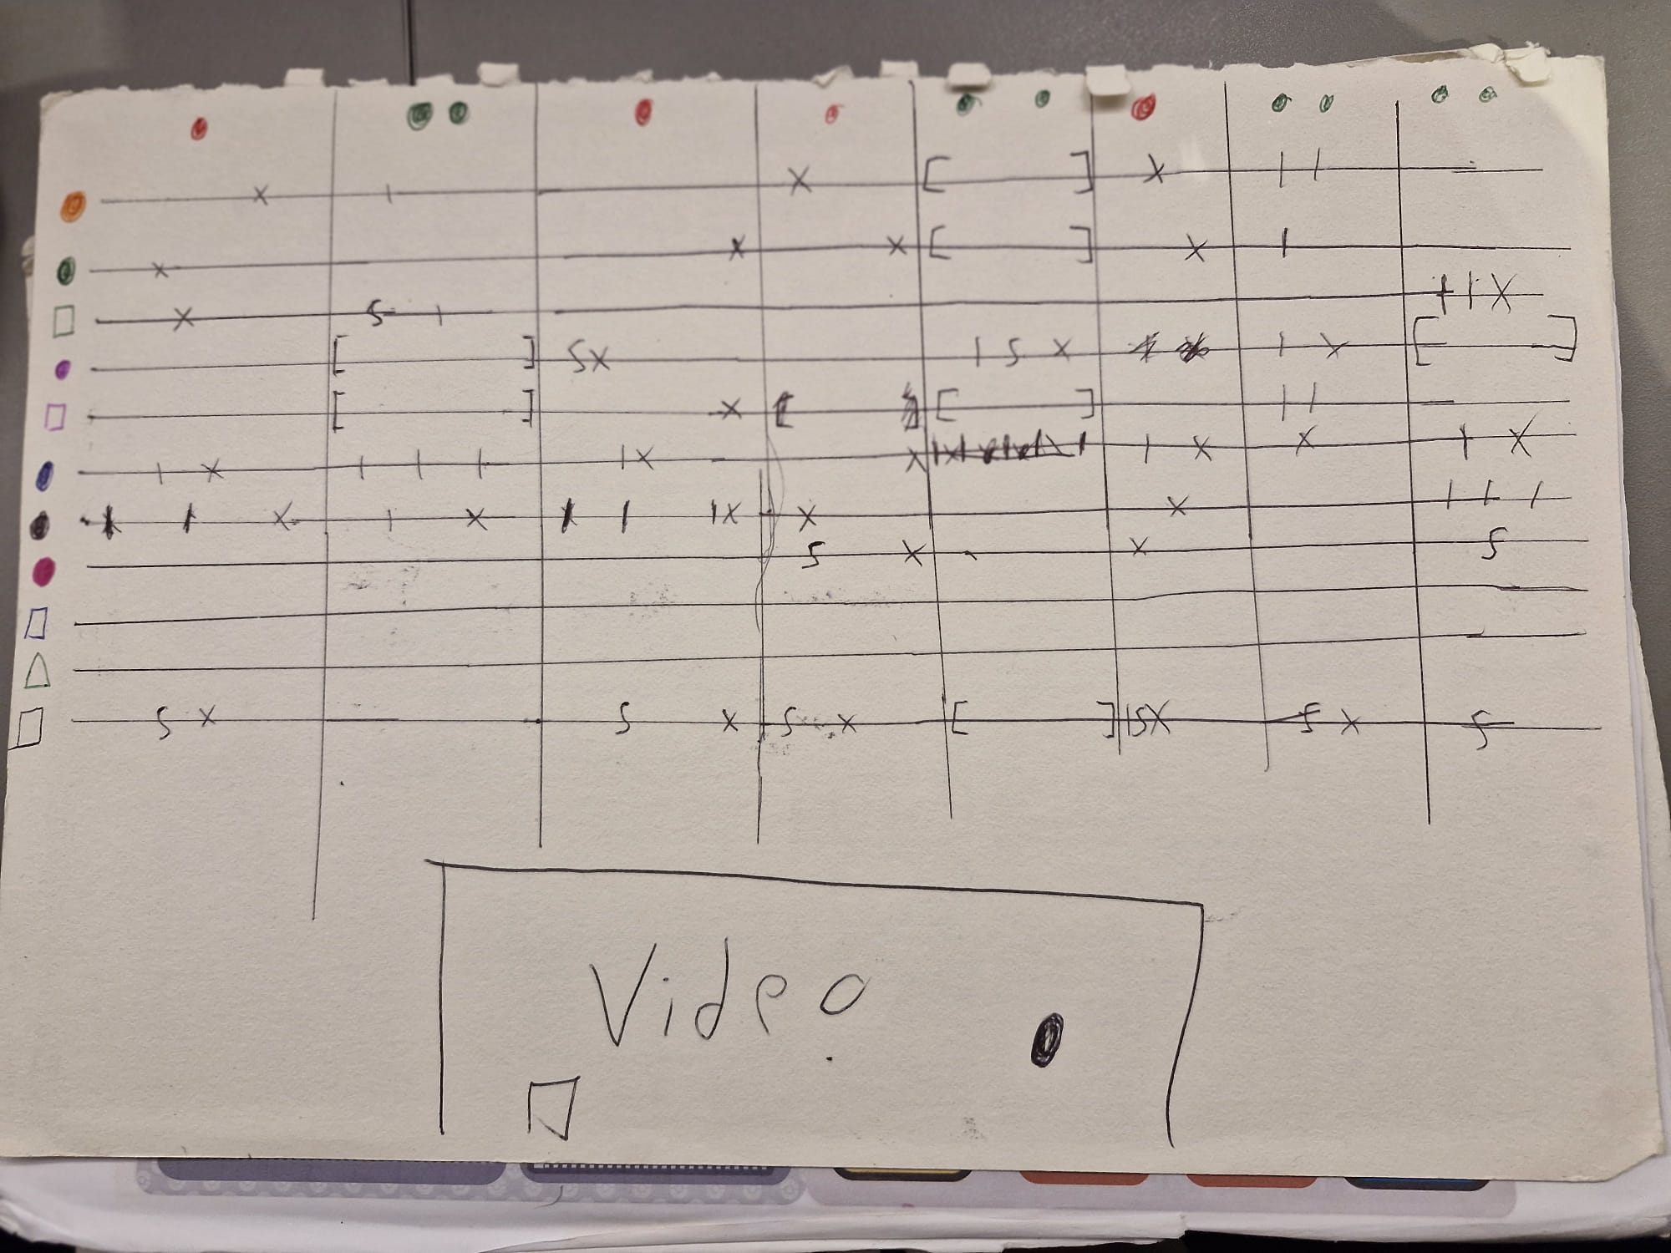

Step 2: Planning implementation

Firstly, we need to compile all the videos into one longer video and place it into one and put it into the processing page. We need to make it so that the video plays from the start till the end with no issues.

Then, we need to write some code that will detect changes in the pokemon to show the above states (if a pokemon is present or not and if it got a KO or Fainted)

If given the time, I will also make a line of code with interactable buttons to make the user be able to go from one battle to the other, whilst matching the current states with the diagram.

Step 2: The actual data

Video links

All the Pokémon battle links

<https://replay.pokemonshowdown.com/gen9natdexdraft-2167979889>

<https://replay.pokemonshowdown.com/gen9natdexdraft-2172829878>

<https://replay.pokemonshowdown.com/gen9natdexdraft-2177189107>

<https://replay.pokemonshowdown.com/gen9terapreviewnatdexdraft-2181423575>

<https://replay.pokemonshowdown.com/gen9natdexdraft-2192398803>

<https://replay.pokemonshowdown.com/gen9natdexdraft-2196606815>

<https://replay.pokemonshowdown.com/gen9natdexdraft-2207364051>

<https://replay.pokemonshowdown.com/gen9natdexdraft-2212344755>

(these have all been compiled into one video)

Statistics for each battle:

